One master GUI is also developed which can be used to train any classifier and compare its performance to other trained classifier. The master GUI follows same flowchart shown in Fig. 5.1. The data is loaded the same way as any individual GUI, however, the parameter selection is different for each classifier. Once the classifier is selected, a child GUI is launched which gives access to parameters of only the selected classifier. The master GUI is shown in Fig. 1

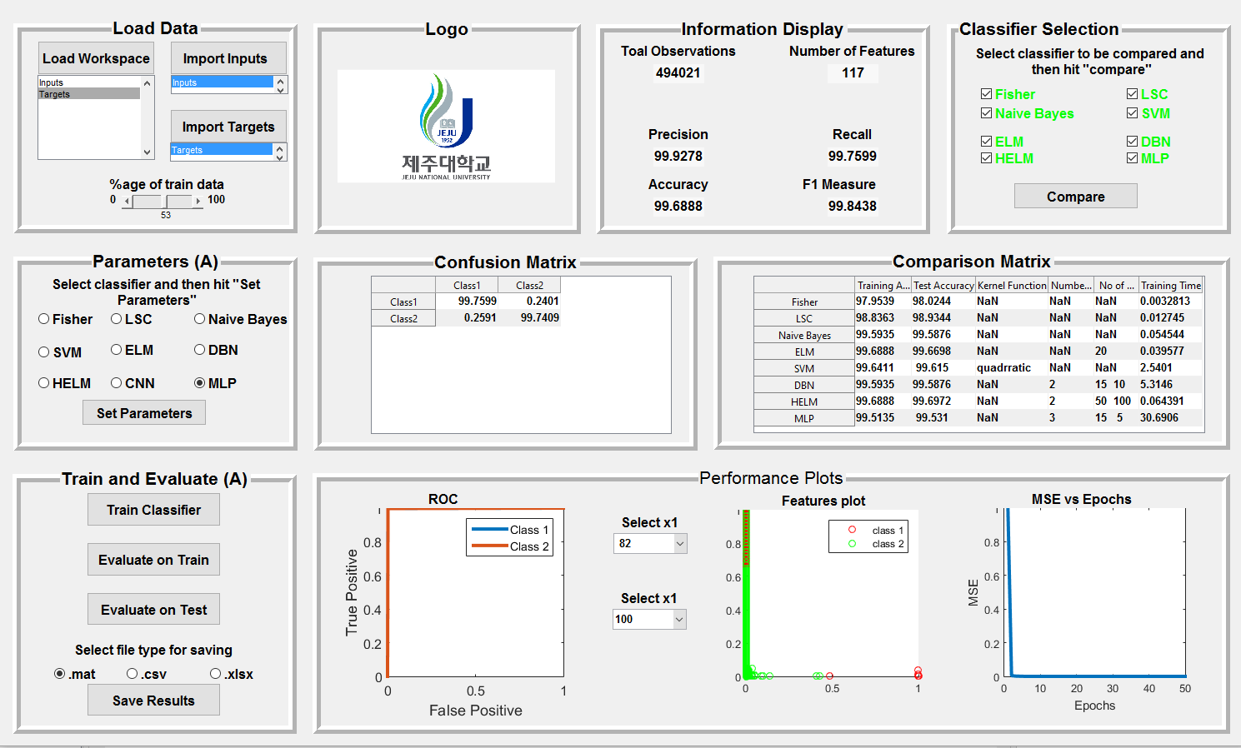

1

6

7

4

8

5

2

3

Figure 1: Outlook of master GUI

As shown in the Fig. 1, the master GUI has three main parts; part one is comprised of panels 1 to 3 (highlighted in green color), part two is comprised of panel 4,5 and 6 (highlighted in blue color) and part 3 is comprised of panel 7 and 8 (highlighted in red color). Out of these three main parts, part one is used to train and evaluate individual classifiers, part two is used to visualize performance of the classifier and part three is used to compare the performance of trained classifiers. The constituent panels are described in the following section.

### Panel 1: Load Data

This panel is used to load data from workspace. Inputs and Targets should be loaded in MATLAB workspace first. “Load workspace” button will import all the variables that are loaded into workspace into GUI space and will appear in the list box below the button. Out of those variables, Inputs can be imported by selecting corresponding variable from the list box and then hitting “Import Inputs”. Similarly, targets can be imported by selecting corresponding variable from the list box and then hitting “Import Targets”. Once the inputs and targets are imported, the slider can be used to set percentage of inputs which will be used for training the classifier.

### Panel 2: Parameters

This panel is used to select the classifier which we want to train and then set its parameters. Select the classifier which is to be trained and then hit “Set Parameters” button. It will launch a child GUI to set the parameters of corresponding classifier. GUIs for setting parameters of classifiers are similar to the parameter panels if their respective individual GUIs.

### Panel 3: Train and Evaluate

This panel is works exactly the same as the corresponding panel shown in Fig. 5.2. The only difference is that this panel trains any classifier selected in panel 2 instead of any specific classifier. All the core mathematical functions and algorithms discussed in previous chapters run behind this panel.

To train a classifier

1. Import inputs and targets
2. Select classifier to be trained in Parameters panel
3. Hit “Set Parameters”. It will launch a child GUI for parameters of that classifier
4. Set the parameters
5. Then hit the “Train Classifier” button
6. Once the classifier is trained, it will be saved in the memory. Name of the classifier in “module selection” panel will turn green, showing that this classifier is available for comparison

### Panel 4, 5 and 6: Results

The contents of these panels are not accessible to users. They are only used for observing the results and performance of trained classifiers, so they are accessible to GUI callback functions only. In panel 4, information about the inputs (number of observations and number of features) is displayed. Once the classifier is trained, its performance measures (precision, recall, accuracy, F1 measure) are also displayed here. Result panels are shown in Fig. 2

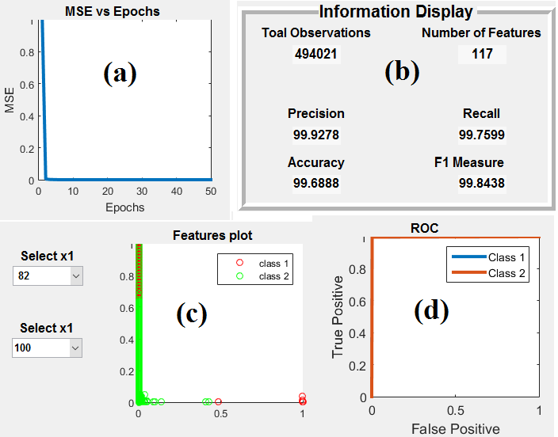

Figure 2: Results panels for Master GUI. **(a):** MSE vs number of epochs, **(b):** Primary information display panel **(c):** Feature scatter plot panel, features can be visualized in 2D **(d):** ROC curve

### Panel 7: Classifier Selection (For comparison)

This panel is used to select the trained classifiers for comparison. There are 8 check on this panel, one for each classifier. When the GUI is launched, it searches for the trained versions of these classifiers. If there are any trained versions of the classifiers present in the memory (saved from earlier sessions), the font color of corresponding classifier name will change to green. Font color of classifiers names not found in the memory will become red automatically.

Once the classifiers are detected, user can select the ones he/she wants to compare. It is to be noted that only those classifiers can be selected for comparison which are already trained. If a classifier is not trained, it should be trained first by accessing panels 1-3. Once the classifier is trained, font color of its corresponding check box in panel 7 will automatically turn green.

### Panel 8: Comparison Results

Comparison results can be visualized in this panel. Although comparison between the stated classifiers cannot be accurate because these classifiers work on different principles and are designed for different problem domains, we can still get an idea which classifier to choose given the input data. Performance comparison can be done in three measure; training accuracy, test accuracy and training time. Training and test accuracy indicates the classification performance while training time indicates speed of the classifier.

Comparison can be done as follows

1. When this GUI is launched, comparison section will search for trained classifiers. If it find trained classifiers, corresponding classifier name in the selection module will become green, otherwise it will be red.
2. If some classifier is not trained, font of its name will be red. If the user go to classifier section and trains a specific classifier, name of classifier will turn green automatically in comparison sedction.
3. First, select all the classifiers you want to compare
4. Second, import inputs and targets. These inputs and targets should be exactly the same on which the classifiers are trained.
5. Hit compare button
6. Comparison results for all the selected classifiers will be shown in table.

Following performance parameters are used for comparison

* Training accuracy
* Test accuracy
* Training time